Prefixes
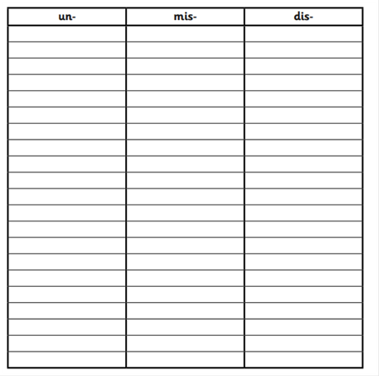
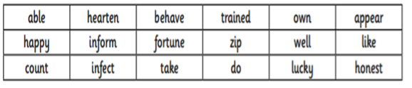
Sort these words into the correct boxes (be careful some words may appear in more than one box):

