Multiplication Squares
You will need: Game board; two dice; two different coloured crayons
How to play:
- Roll two dice and multiply. Eg. A 6 and a 4 would equal 24
- Look for the product on the game board and draw ONE line by connecting any two dots
- Play passes to next player and repeats
- Player to close the ‘square’ claims the square and colours it in
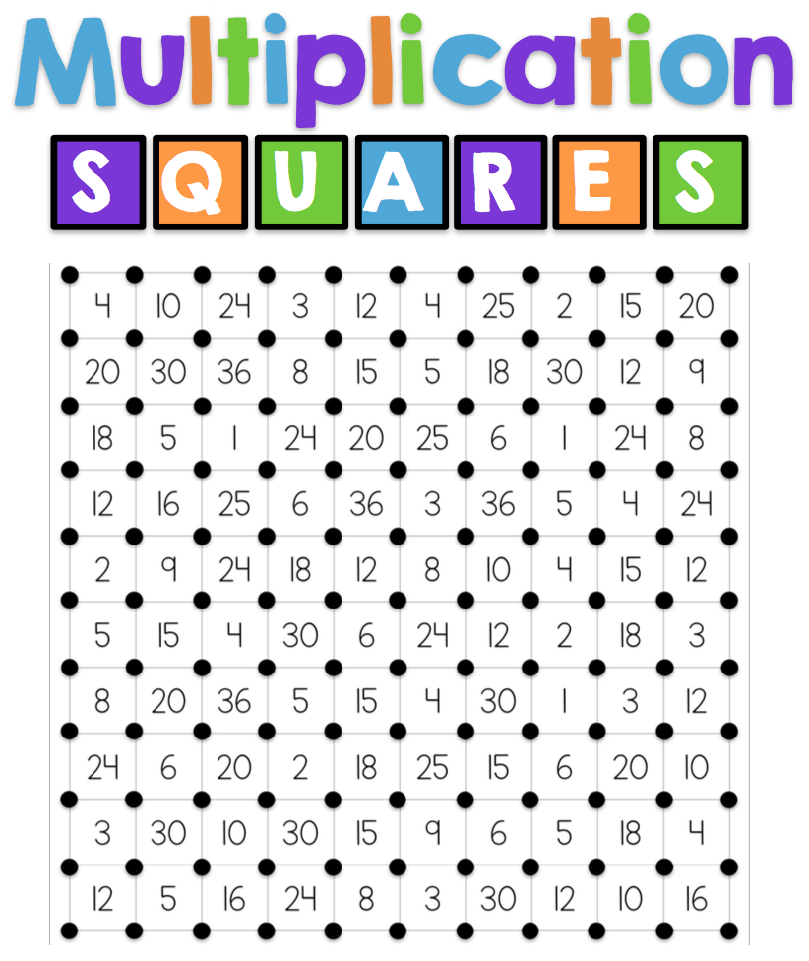
- The winner is the player with the most squares at the end of the game

