Easter Holiday Challenges
Challenge 1
- Create a junk 3D model of our solar system.
- Research Neil Armstrong’s visit to the moon.
- Create a documentary about Neil Armstrong’s visit to the moon using your research and 3D model.
Challenge 2
- Learn new skills in the garden, this could be something to do with sport, wildlife or gardening for example.
- Once you have mastered your new skills you could create a guide to teach somebody else your new found skill such as a brother, sister or adult at home.
Challenge 3
- Bake a story (borrowed from Brownies). Choose a story you would like your creation to be about. It could be from a book, TV show or song.
- Once you have made your choice, think carefully about what happens in the story line. Come up with your own recipe or decorative design to show the story.
- For example you could make Queen of Hearts jam tarts from Alice in Wonderland.
Challenge 4
- Backwards cooking (borrowed from Guides) – MAKE SURE YOU DO THIS SAFELY WITH AN ADULT.
- Step 1: Cook something over a fire using a stick.
Step 2: Cook something over a fire using a can.
Step 3: Cook something in the embers of a fire.
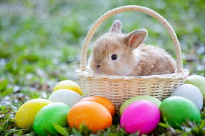

Please note: you do not have to complete each challenge, these are just some suggestions as to how you could keep yourself busy over the next couple of weeks.

