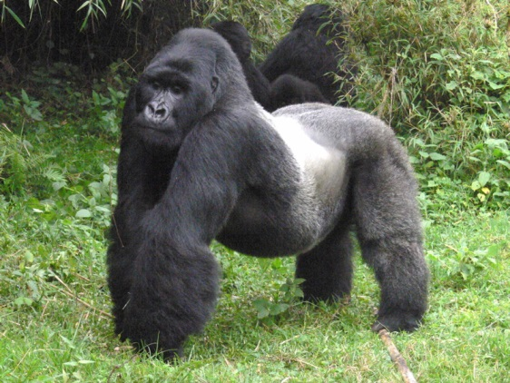
Gorillas are animals that mainly live in forests in Africa. It is the largest of the living primates and the last member of the ape family. The gorilla is big, with a big chest and shoulders. The arms are longer than the legs and the fully adult male mountain gorilla is twice as large as the female.

The Gorillas
Introduction
Would you like to find out more about Gorillas? If so, read on. Gorillas are huge animals that mainly live in dense, tropical forests in Africa. Unsurprisingly, it is the largest of the living primates and sadly the last member of the ape family. The gorilla has a large, thick trunk, along with huge, muscular chest and shoulders. Shockingly, the gorilla’s arms are much longer than it’s legs and when fully grown the adult, male mountain gorilla is twice as large as the female.
