Acute angles are less than 90°.
13)
Acute
Key
Obtuse angles are more than 90°, but less than than 180°.
- Choose 3 colours, fill in the key, then colour the angles as appropriate.
Obtuse
- Estimate the sizes of the angles by comparing them to right angles and straight lines.
- Use a protractor to measure the angles.
11)
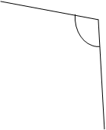
8)
Right angle
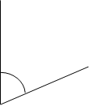
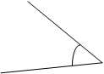
15)
14)
12)
10)
9)
7)
6)
5)
4)
3)
2)
1)

11)
12)
13)
14)
15)

6)
7)
8)
9)
10)
Estimates:
1)
2)
3)
4)
5)

